**NAME: ASJID TAHIR  
CLASS: BSCS  
SECTION: 2B2**

**LAB TASKS: DLD LAB**

**ROLL NO: 19P-0085**

**QUESTIONS:  
Task 01:**

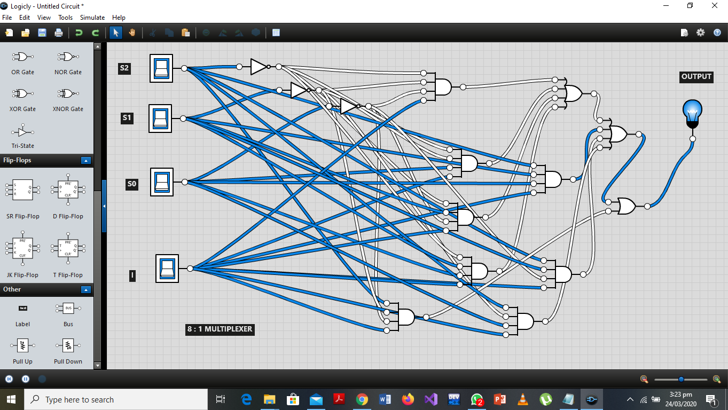

**TASK 2**

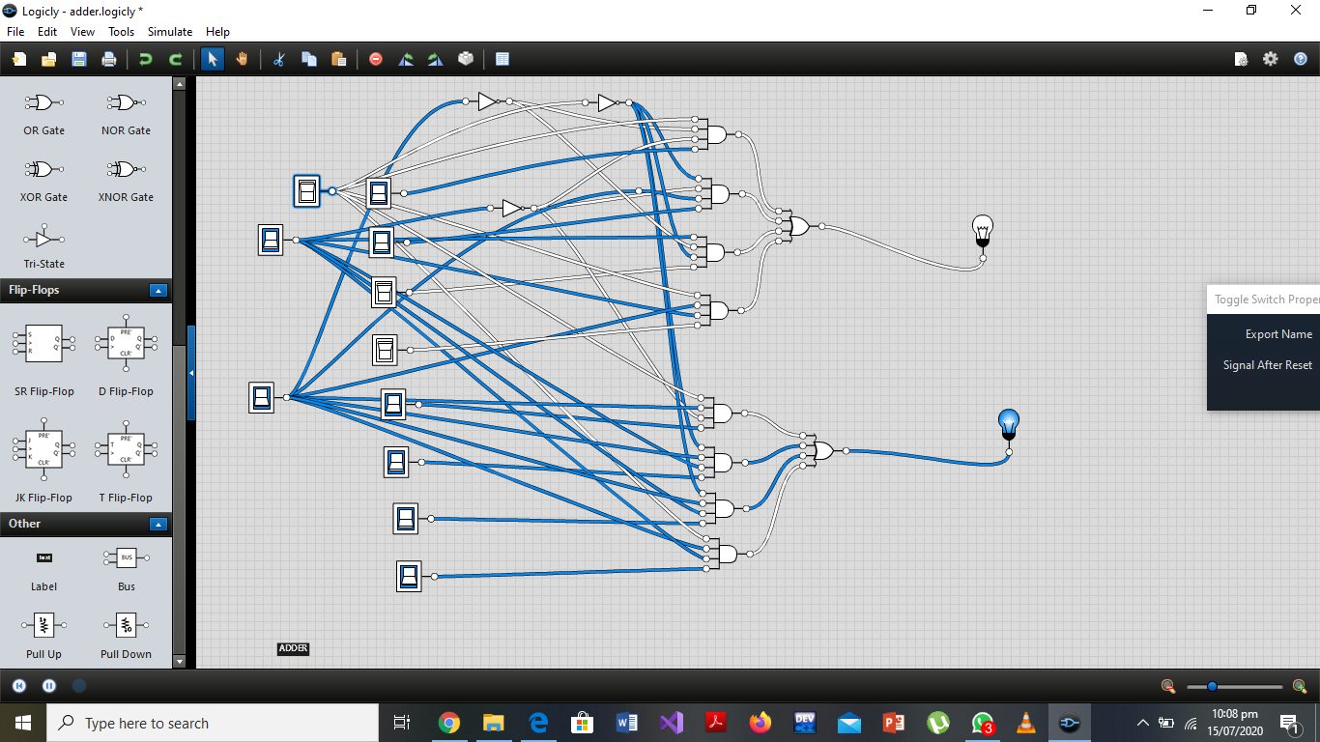

**Task 3**

